Disability Inclusive Meetings

An Operational Guide

Contents

Acknowledgements 3
Acronyms 4
Introduction 5
Key concepts of disability-inclusive meetings 10
Planning disability-inclusive meetings 16
Conducting disability-inclusive meetings 26
Conclusion 29
Glossary 30
Resources 38
Checklists 40
Annex 45

Acknowledgements
This Guide was prepared by the ESCAP Social Development Division, under the overall direction of Nanda Krairiksh, Laura Lopez and Patrik Andersson.
The Guide was drafted by Aiko Akiyama and Jake Hollis.
Helpful comments were received from Muhammed Atif, Chol O Han, Ikumi Kawamata, Dong Ho Kim, Marco Roncarati, Tenzin Seldon and Chaveemon Sukpaibool.
The team is grateful to members of the Working Group on the Asian and Pacific Decade of Persons with Disabilities, 2013-2022, for their inputs and comments provided during the preparation of the report. Particularly insightful feedback was provided by Disability Rights Promotion International, Inclusion International, the World Federation of the Deaf, the World Federation of the Deafblind, as well as the Governments of Indonesia, Pakistan and the Republic of Korea.

Acronyms

APCD Asia-Pacific Development Centre on Disability
ASL American Sign Language
BSL British Sign Language
CRPD Convention on the Rights of Persons with Disabilities
DAISY Digital Accessible Information System
DET Disability Equality Training
DO IT Disabilities, Opportunities, Internetworking and Technology
DPO Disabled People’s Organisation
DDRC Developmental Disabilities Resource Centre
ECOSOC Economic and Social Council
ESCAP Economic and Social Commission for Asia and the Pacific
IS International Sign
NDA National Disability Authority (Ireland)
W3C World Wide Web Consortium
WCAG Web Content Accessibility Guidelines

Introduction

Why disability inclusion anyway?

Six hundred and fifty million people in Asia and the Pacific have some form of disability. That is one sixth of the region's population. This number is expected to rise over the coming decades due to factors including population ageing; chronic health conditions; road traffic injuries; natural disasters, and conflict. The fact that disability is often a consequence of other development issues — such as those listed above — makes it imperative to build an inclusive regional development dialogue, in which the voices of persons with disabilities are heard. From poverty reduction to gender equality; from social protection to disaster risk reduction, there are very few areas that cannot benefit from the perspective of persons with disabilities.
The slogan, “Nothing About Us Without Us” has become a popular byword for the importance of persons with disabilities acting as decision-makers over all aspects of their lives. Indeed, individuals with a diverse range of disabilities have been increasingly active in international decision-making processes in recent years. Advocates with disabilities were instrumental in formulating the United Nations Convention on the Rights of Persons with Disabilities (CRPD, 2006), which itself affirms the right of individuals with disabilities to participate in decision-making processes. Meanwhile, an extremely wide range of disability-focused NGOs around the world have consultative status in the UN Economic and Social Council (ECOSOC).
Over the past two decades, the United Nations Economic and Social Commission for Asia and the Pacific (ESCAP) has spearheaded the movement for the realisation of the rights of persons with disabilities in the region. ESCAP is currently promoting the implementation of the Incheon Strategy to “Make the Right Real” for persons with disabilities in Asia and the Pacific — which itself benefited heavily from the inputs of persons with disabilities. The Strategy provides the region and the world with the first set of time-bound, interrelated and regionally agreed-upon disability-inclusive development goals.
Disability is increasingly being mainstreamed into wider development strategies, as demonstrated by the 2030 Agenda for Sustainable Development and the Sendai Framework for Disaster Risk Reduction — both of which acknowledge that “persons with disabilities and their organisations are critical” to meaningful policymaking. For more detailed information on the rights of persons with disabilities, see the Convention on the Rights of Persons with Disabilities.

Why this Guide?
The Working Group on the Asian and Pacific Decade of Persons with Disabilities, 2013-2022, was established in order to provide member States with technical guidance on the implementation of the Incheon Strategy. The Working Group is composed of 15 government members and 15 representatives of civil society organizations, most of which are disabled people’s organisations (DPOs). At its inaugural meeting in 2014, the Working Group called for the creation of a guiding document for the planning and coordination of meetings that are fully inclusive of participants with diverse disabilities. This Guide is a direct result of that request, and it seeks to offer a comprehensive set of practical suggestions for meeting organizers at all levels.
The Guide builds particularly on the Incheon Strategy’s second and third goals. The second goal promotes the participation of persons with disabilities in political processes and decision-making. The third goal, meanwhile, emphasizes the need to enhance the accessibility of the physical environment, public transportation, knowledge, and information and communication systems.
The term ‘disability-inclusive meeting’ is used here to denote meetings that are inclusive of disability perspectives at both the thematic and participatory levels. This means that, regardless of whether a meeting’s theme strictly refers to ‘disability’ per se, the perspective of individuals with disabilities is incorporated into the subject of discussion. At the logistical level, disability-inclusive meetings promote the removal of all barriers to the full and equal participation of persons with disabilities.

What does this Guide provide readers with?
This Guide offers ESCAP member States, stakeholders and other interested readers a framework for the planning of disability-inclusive meetings. It consists of three chapters:
1) Key concepts of disability-inclusive meetings
2) Planning disability-inclusive meetings
3) Conducting disability-inclusive meetings
These chapters contain principles and practical advice to support meeting organizers in the planning process as well as during the meetings themselves. A glossary is included at the end of the Guide, which provides definitions of terminology. A list of resources that have informed this Guide is also included.
This Guide was prepared in consultation with persons with disabilities. A draft of the Guide was reviewed by members of the Working Group at its Second Session in New Delhi, India, in March 2015. As such, the Guide is built on the knowledge and expertise of leading DPOs and CSOs, as well as representatives of ESCAP member States.
There are a series of checklists at the end of the Guide, to provide specific guidance in addition to that which is offered in the main chapters. These checklists build on the themes of each chapter, providing point-by-point actions that should be taken in order to effectively plan and conduct disability-inclusive meetings. It is hoped that throughout the course of planning meetings, organizers will be able to continually refer to this Guide and fulfil each action point, thereby filling each empty box: with a tick:

Representatives of ESCAP member States, civil society organizations and disabled people’s organisations gather in Incheon, Republic of Korea, in 2012, to adopt the Incheon Strategy to “Make the Right Real” for Persons with Disabilities in Asia and the Pacific.

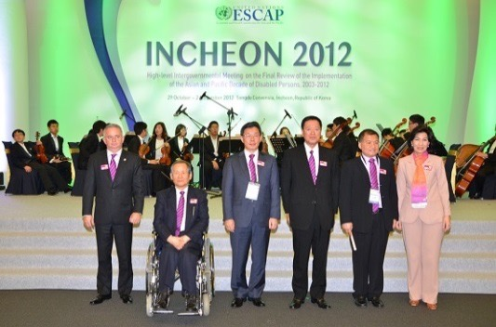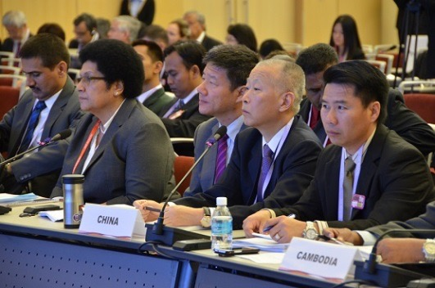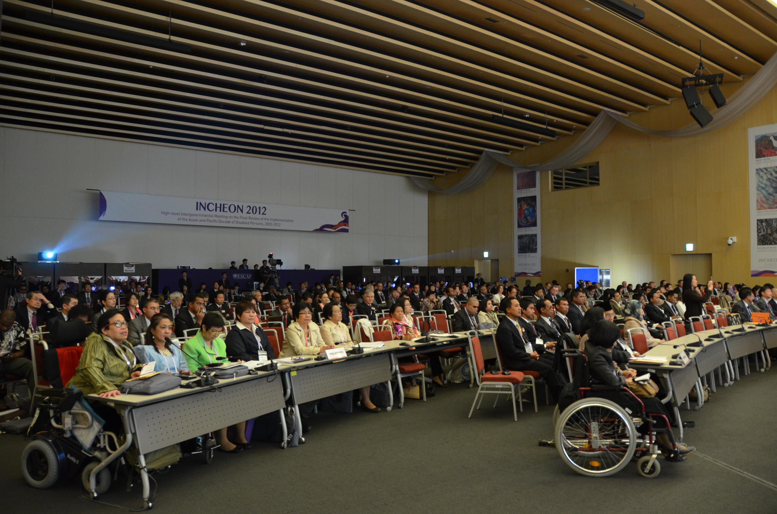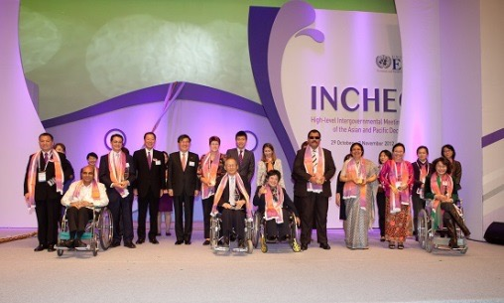

Chapter 1

Key concepts of disability-inclusive meetings
This chapter offers explanations of three concepts that are essential to the planning of disability-inclusive meetings: accessibility, reasonable accommodation and universal design. Firstly however, it is important to consider the meaning of disability itself and the significance of the rights of persons with disabilities, in addition to the diversity of disabilities that exist.

1.1 What is disability?
In order to plan and conduct disability-inclusive meetings, it is important to first become clear on what ‘disability’ actually means. The CRPD states that disability is a result of the intersection of impairments with environmental, legal, informational and attitudinal barriers. In light of this recognition, the CRPD and the Incheon Strategy utilize the language of human rights to call for societal interventions to create a barrier-free society. In the context of organizing and coordinating disability-inclusive meetings, an awareness of barriers that may inhibit or prevent the active participation of persons with disabilities is crucial. Most of the barriers in the way of the participation of persons with disabilities in meetings are man-made; the positive implication of this recognition is that the very same barriers can be removed.

1.2 Diversity of disability
There exists a great spectrum of disabilities. Some persons with physical disabilities use wheelchairs, crutches and other mobility aids as a result of a reduction in the function of their limbs and other body parts. Persons with visual disabilities include those who are blind and those with varying degrees of partial sightedness. Persons with hearing disabilities include those who are deaf and those who are hard of hearing. Persons with intellectual disabilities include those who have difficulties with cognition and intellectual functioning. Persons with psychosocial disabilities, meanwhile, face challenges in their mental and emotional functioning in relation to their surroundings. Persons with developmental disabilities include those who experience difficulties in learning, just one example of which is autism. However, even among persons with autism, behavioural patterns and needs are extremely diverse. Many disabilities can be for much of the time relatively inconspicuous – such as lung diseases, immunological diseases and other chronic illnesses. However, just because one person’s disability might be less visible than another’s, does not mean that they do not require special assistance or accommodations to be made. There are also persons with multiple disabilities. Persons who are deafblind are both deaf and blind — though this can entail a variety of combinations of levels of hearing and sight. For example, one deafblind individual may be completely blind and hard of hearing; another may be partially sighted and profoundly deaf.
The above list is far from exhaustive; it merely seeks to give an impression of the heterogeneity of disability. It is clear that an extensive and thorough range of considerations and measures may need to be taken in order to create accessible environments for persons with different disabilities. Having considered the meaning of disability and the significance of the diversity of disability, meeting organizers are likely to benefit from an understanding of the three core principles described below.

1.3 Accessibility
Accessibility is the degree to which both the physical environment and information can be used or accessed by as wide a group of people as possible. As such, accessible physical environments or information services are those that can be used or accessed by all individuals, irrespective of any disability they may have. In order to organize a meeting in which persons with diverse disabilities are able to participate on a full and equal basis with others, the concept of accessibility is essential.
The CRPD identifies four key areas where the concept of accessibility is vital: the physical environment; transportation; information and communications, and other facilities and services open to the public. Since each of these areas is relevant to the planning and coordination of disability-inclusive meetings, specific examples of accessibility measures that can be taken in each case are offered in the following chapters. For now, it is worth noting that genuinely disability-meetings are built upon a holistic approach to accessibility. Efforts to locate a meeting venue that ensures physical accessibility to participants with mobility disabilities – such as through the provision of ramps – may come to nothing if accessible forms of transportation have not be provided, preventing those very same participants from travelling to the meeting venue.

1.4 Universal design
The CRPD defines universal design as “the design of products, environments, programmes and services to be usable by all people, to the greatest extent possible, without the need for adaptation or specialized design”. The concept asserts that anything and everything should be designed in order to be accessible not only to persons with diverse disabilities, but more generally to the broadest possible spectrum of humanity.
The concept of universal design was coined by the American architect, educator and product designer Ronald Mace, to describe the design of the physical environment and products so that they could be usable by all individuals regardless of the ability, age or life status. Experts in the fields of architecture, product design, engineering and environmental design collaborated to establish seven principles of universal design.
Universal design recognizes the common needs shared by persons with and without disabilities. For example, public buildings designed with ramps at entrance ways allow for the easy mobility not only of persons with mobility disabilities, but also people with heavy luggage on wheels; parents with strollers; pregnant women; people with injuries, and older people, for whom a sloping surface is often easier to use than steps. Similarly, in the realm of information accessibility, television programmes that are produced from the outset with the provision of subtitles also constitute a form of universal design, since subtitles enhance the accessibility of programmes not only for persons who are deaf or hard of hearing, but also people watching in noisy environments, as well as those who are not proficient in a particular language.
For organizers of disability-inclusive meetings, the planning process can become inestimably more straightforward by selecting – where available – venues, transportation, informational materials, ICT systems and other services and products that incorporate the universal design approach.

1.5 Reasonable accommodation
The CRPD defines reasonable accommodation as “necessary and appropriate modification and adjustments not imposing a disproportionate or undue burden, where needed in a particular case, to ensure persons with disabilities the enjoyment or exercise on an equal basis with others of all human rights and fundamental freedoms.” To put this into slightly simpler language, the accommodation part of the term refers to the legal responsibility of duty bearers to provide accessible physical and informational environments, facilities and services for persons with diverse disabilities. The reasonable aspect, meanwhile, emphasizes that such measures should enable the fulfilment of rights without requiring excessive cost, or burden to duty bearers. An act of reasonable accommodation comes as a result of a request made by individual rights holders.
The concept of reasonable accommodation makes use of human rights discourse, and in particular, the relationship between duty bearers and rights holders. In countries where reasonable accommodation is protected by law, questions as to what qualifies as reasonable can be disputed in court. Moreover, in countries that are party to the CRPD’s optional protocol, these questions can also be elevated, when necessary, to the UN Committee on the Rights of Persons with Disabilities. At a practical level, reasonable accommodation may mean that the management of a meeting venue installs ramps in order to enable access for individuals with assistive devices such as wheelchairs or crutches to move around freely. Similarly, meeting organizers might provide interpreting and captioning services for persons who are deaf, hard of hearing or deafblind on the basis of reasonable accommodation.

1.6 The interrelation of the three core concepts
To better understand how the concepts of accessibility, reasonable accommodation and universal design relate to one another, consider the example shown in Figure 1. The addition of a ramp onto the side of an existing building enhances the accessibility of the building to persons with mobility disabilities. The problem with the ramp, however, is that it is located away from the main entrance. This reduces the inclusiveness of the entrance and reinforces a degree of separation between persons with and without mobility disabilities. The ramp may have been installed after a request made by a person with a disability on the basis of reasonable accommodation. If, by contrast, the building had originally been designed in line with universal design, and a ramp had been integrated into the main entrance, this process and the construction costs could have been avoided, and the building would be more inclusive, not only of persons with mobility disabilities, but also of elderly people, parents with strollers, and people carrying heavy luggage.

Figure 1: Accessible, but not inclusive

Image description: The image shows a building with two separate entrance routes. The first entrance route is a stairway that leads directly to the building’s doorway, and which a number of people are walking up. The second, far longer entrance route consists of a series of ramps that persons who use wheelchairs must use to access the building. One person about to climb the stairway points a person using a wheelchair towards the ramp, as if to reinforce the separation between persons who do and do not have mobility disabilities.
Genuinely disability-inclusive meetings should be planned with due consideration of the three interrelated concepts described above: accessibility, reasonable accommodation and universal design. The next chapter offers practical advice for the planning of meetings that are made accessible through the use of universally designed elements when possible, but which also consider questions of reasonable accommodation when necessary.

Chapter 2

Planning disability-inclusive Meetings
This chapter provides principles and practical recommendations for meeting organizers during the planning process of a disability-inclusive meeting. Ideas are offered for various stages of the planning process, including:
- Viewing the meeting’s theme from a disability perspective;
- Formulating a programme and sending invitations;
- Selecting an accessible venue and hotel;
- Arranging accessible information, communication and transport services;
- Budgeting.

2.1 Viewing the theme from a disability perspective
It is always worthwhile to consider how the theme of a meeting is likely to be viewed from a disability perspective. It should not be assumed that if a meeting’s theme does not explicitly address ‘disability’, it is therefore not relevant to persons with disabilities. Just about any topic is likely to have an important disability dimension – from information and communication technology to gender equality. Moreover, as disability is increasingly mainstreamed into the agendas of policymakers throughout Asia and the Pacific, meeting organizers should expect to see greater participation from persons with disabilities. Meeting organizers therefore have an opportunity to add both depth and dynamism to their events by incorporating into their plans an explicit consideration of how their theme relates to disability.

2.2 Sending invitations
Invitations should be sent far in advance of the meeting to allow for adequate preparation time, and especially when accessibility measures are required for participants with disabilities. In order to understand the specific needs of all participants, meeting organizers should attach an accessibility request form along with the invitation. This provides each participant with the opportunity to make their requirements clear. See Annex 1 for an example of a sample accessibility request form. It is also very important to send invitations in accessible formats (see section 2.6).

2.3 Formulating a programme
A carefully planned meeting programme can greatly enhance the experience of all participants; not only those with disabilities. A critical issue here is to allocate enough time for substantive sessions and breaks during meetings, factoring in the communication needs of persons with different disabilities. For example, deaf or deafblind persons need sign language or tactile sign language interpreters and persons with developmental or intellectual disabilities may need facilitators who interprets technical and complex terms into simpler language. Persons using respirators, persons with psychosocial disabilities, and support personnel such as interpreters benefit from having frequent breaks. Wheelchair users might benefit from sufficiently long breaks to travel to and from an accessible bathroom.

2.4 Selecting an accessible venue and hotel
In order to choose a reasonably good meeting venue and hotel, organizers can benefit from the insights of persons with disabilities. This provides an opportunity to gauge the extent to which existing facilities, information and services are in line with universal design principles. It is also important to ensure that staff at candidate venues are willing to make necessary adjustments and modifications to prepare for disability-inclusive meetings.
Special attention should be paid to a venue's physical features in terms of: space, height, surface materials and gradients. By considering the experience of a person who uses a wheelchair, crutches, or is blind as they move around the building, it will become clear that certain venues are easier to access than others. As a rule of thumb, venues that have more space are generally more accessible. Moreover, spacious venues are more practical if additions and modifications are required, such as mobility ramps or additional furniture. See Annex 2 for a sample floor plan of a mobility-accessible corridor, and see Annex 5 for specifications on accessible mobility ramps.
Once a meeting venue and hotel are selected, it is important to identify what modifications may be needed to make the venue and place of accommodation fully accessible. It is important to clarify at the onset who will bear the cost of making necessary modifications, and to allocate enough time for their completion.

2.5 Arranging accessible information and communication services
It is crucial for meeting organizers to ensure that information and communication services are made accessible to persons with different disabilities. Information disseminated both prior to and during the meeting, such as invitation letters, guidance notes about travel arrangements, background papers, websites and videos should be available in accessible formats.

2.5.1 Fonts
Since written materials are a very common means of communication, it is important to ensure that fonts used are as readable as possible. Meeting organizers should therefore be aware that different fonts can make a significant difference to persons with print and intellectual disabilities. In general, clear, large-sized fonts are easier to read. Documents that use fewer different fonts are easier to read than those with many, which can be confusing for some readers. Serif fonts such as Times and Times New Roman are considered the most readable for printed materials, whereas for content that is read from a screen, sans serif fonts, such as Arial and Verdana can be clearer. However, for very high quality screens that can display fonts with clarity, serif fonts may be as readable as sans-serif.

2.5.2 Braille
Some persons with visual disabilities use Braille, a tactile writing system using embossed dots on paper. One commonly held misconception about Braille is that it is universal. In fact, every spoken language has its own form of Braille. Upon request, meeting organizers may be required to translate meeting documents into Braille. As a general rule, Braille uses three sheets of paper for every one page in standard print. It is highly recommended that organizers and managers of meeting venues and hotels have their name cards with Braille translations on them. These name cards can also serve as advocacy tools to raise awareness on the importance of information accessibility. Braille labels on elevator buttons can enable blind and partially-sighted persons to move around the venue and hotel independently. It is important for meeting organizers to source Braille translations and printing services early in the planning process.

Figure 2: A business card with Braille translation
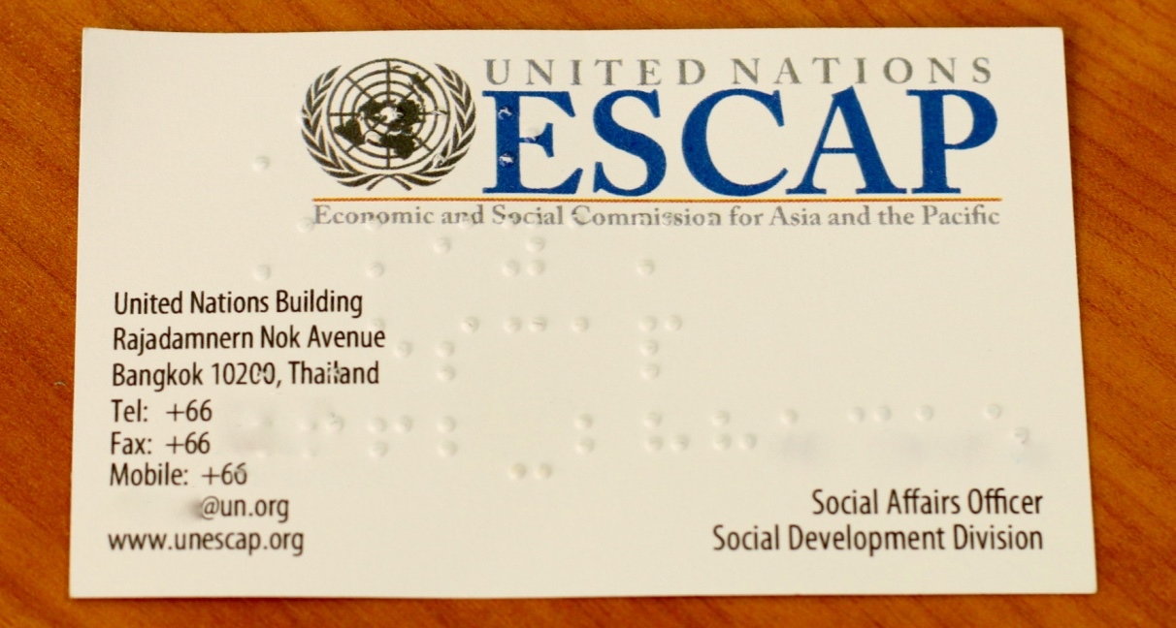

Figure 3: An elevator button with Braille information plate

2.5.3 Sign language interpreters
Many deaf persons and persons who are hard of hearing use sign language as their primary means of communication. Sign languages use body language and physical movement rather than audible sound to convey meaning. Expressions of sign language involve a combination of finger shapes, bodily movements and facial expressions.
A common misconception is that there is one dominant sign language, used worldwide. In fact, there is a great diversity of sign languages, each with its own structure and syntax. Indeed, even two sign languages used in English-speaking countries — American Sign Language (ASL) and British Sign Language (BSL) — are quite distinct from one another. International Sign (IS) is a dynamic and sophisticated signed communication system that is often used at international meetings.
Sign language interpreters facilitate communication between spoken and signed languages. In a meeting with participants who communicate using sign language, meeting organizers should identify the specific needs of participants, and make arrangements for the provision of appropriate sign language interpreters. In case it is not possible to find sign language interpreters who are fluent in the official spoken language of the meeting, organizers may wish to arrange additional interpretation between the spoken language and the languages used by the interpreters.

2.5.4 Guide/interpreters
Deafblind individuals benefit from the communicative assistance of guide/interpreters. Guide/interpreters typically facilitate communication using tactile communication methods, such as Finger Braille, tactile sign language and print on palm, among others. Guide/interpreters work on a one-to-one basis with deafblind persons to act as a bridge between spoken language and tactile communication. Deafblind persons often establish a deep rapport with guide/interpreters, and together they establish a highly individualized system of communication. Guide/interpreters are as much guides as interpreters, since their role is not only to interpret language, but also to guide deafblind individuals on environmental information. Interpreters and guide/interpreters should be allowed regular breaks, meaning that additional interpreters may be needed for rotation — which should ideally take place every 15-20 minutes.

2.5.5 Captionists
Some persons who are hard of hearing or deaf may request the provision of real-time captioning if they do not use sign language. Real-time captioning refers to simultaneous text transcription of what is said, which is then projected onto screens during a meeting.
Real-time captioning can aid understanding not only for deaf persons but also for persons with intellectual and psychosocial disabilities, as well as those who are not proficient in the primary spoken language used in meetings. It also has the added benefit of providing an electronic record of the meeting’s proceedings. Two common formats used by English language captionists are CART and C-Print. However, each country generally has a different captioning system and technology. Captionists may be present at the meeting, or they may alternatively provide their services from another location, by listening to an audio output of the meeting and sending back text via an internet connection.

2.5.6 Note taking services
Note taking offers an alternative to captioning, which may better suit meetings with limited budgets. Note takers produce summarized notes of the main points discussed during a meeting. These notes may be projected onto screens during the meeting, or distributed to participants. Clear, simple summaries of proceedings are useful for all participants, but can be particularly beneficial to persons with intellectual disabilities, who may have trouble understanding verbose or complex contributions to meetings.

2.5.7 Support assistants
Some participants with intellectual disabilities may benefit from having an assistant or facilitator to help them better understand the content of a meeting by summarizing complex speech or text using easy-to-understand words. An example of text from the easy-to-understand version of the Incheon Strategy is compared with the original version, in Figures 3 and 4. It can therefore be useful for the facilitator and participant to meet in advance of the meeting, to discuss its theme, as well as the meanings of any specialized words that are likely to be used. The assistant may also be expected to assist the participant in preparing contributions they may wish to make during the meeting. Similar communication assistants may also be useful for participants with psychosocial disabilities, autism, learning disabilities and aphasia. Meeting organizers may also wish to recruit volunteers to provide further assistance ahead of the meeting.
Figure 4: Indicator 1.1 from the Incheon Strategy
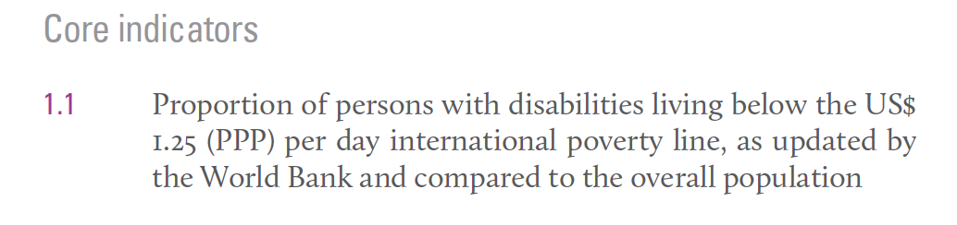

Figure 5: Indicator 1.1 from the easy-to-understand version of the Incheon Strategy
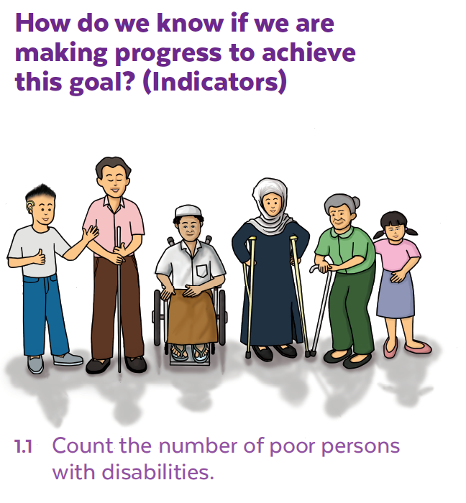
How do we know if we are making progress to achieve this goal? (Indicators)
1.1 Count the number of poor persons with disabilities.

2.6 Arranging accessible transportation
If local public transportation is not accessible, organizers should provide or alert participants to alternative transport. Organizers should identify providers of accessible vehicles and book services far in advance of the start of the meeting. When air travel is used, organizers should identify airlines that provide accessible services for persons with diverse disabilities, and communicate these recommendations to all participants as far in advance as possible.

2.7 Budgeting
A certain portion of a meeting’s budget will necessarily be spent on accessibility measures for persons with diverse disabilities. If the meeting venue, place of accommodation, transportation and other facilities and services follow the principles of universal design, these costs may be minimal. However, as long as universal design remains far from mainstream, meeting organizers are likely to be responsible for certain costs in line with reasonable accommodation. In the case of accessibility modifications made to a property, such as mobility ramps, the cost may be borne in part or in full by the property owner. Guides, interpreters and assistants for persons with disabilities, in addition to accessible materials, facilities and services, may similarly be paid for or subsidized by a combination of the meeting organizers and sponsors, depending on the available budget.
In general, fees for the services of sign language interpreters and guide/interpreters should be on an equal basis with spoken language interpreters. Organizers may wish to explore the possibility of recruiting volunteers to support different aspects of disability-inclusion. Volunteers can be presented with certificates to recognize their support for the event.
The most meaningful measure of a meeting’s disability-inclusiveness is the degree to which participants with diverse disabilities can freely take part in all of its features on an equal basis with others.

Figure 6: Bathroom facilities with accessible features
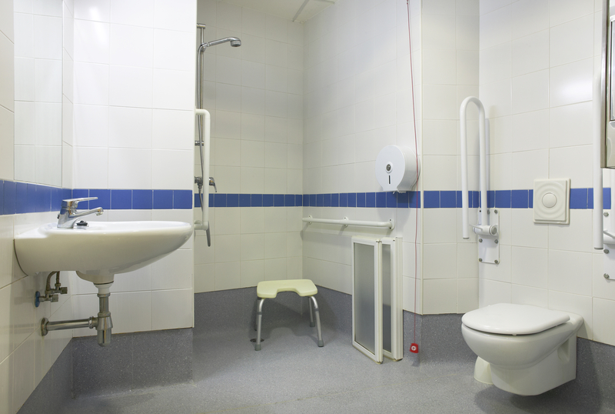

Figure 7: Mobility ramp for wheelchair Figure 8: Stairs with colored strips
users for easy visibility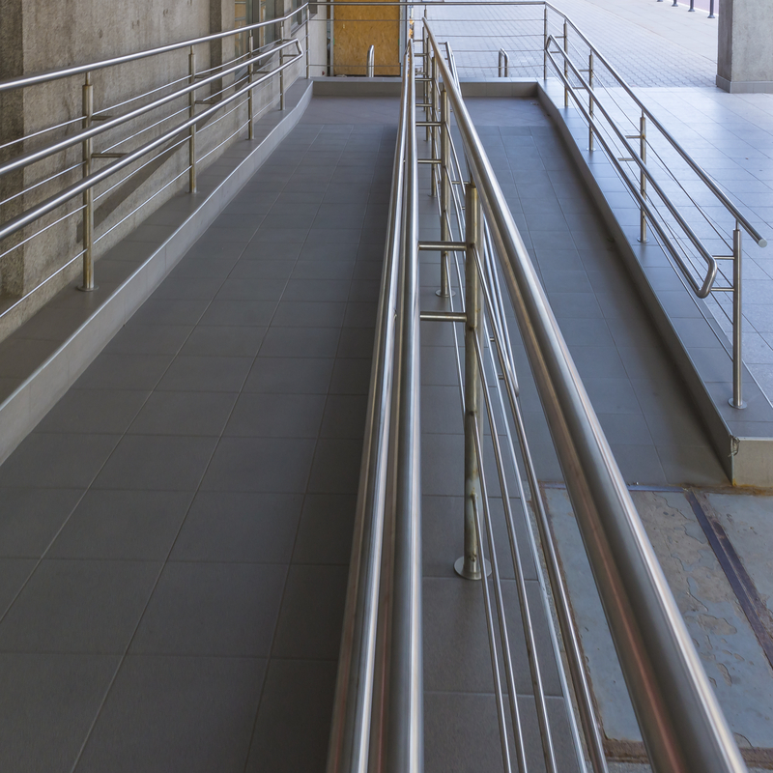

Chapter 3

Conducting disability-inclusive meetings
This chapter offers advice for making final preparations closer to the time of meetings, as well as practical recommendations for their conduct. In addition, suggestions are made about how best to evaluate meetings via feedback from participants. This evaluation process can prove instrumental in establishing good practices and allowing for lessons learned to be incorporated into the planning of future meetings.

3.1 Making final checks of the venue, and sensitizing personnel
While most provisions for the physical layout of a meeting space should be made far in advance of the meeting itself, it is also a good idea to make a final check of the venue closer to date of the meeting. This can help to ensure that nothing is overlooked.
As well as making sure that information and the physical environment are accessible for persons with diverse disabilities, it is also crucial to consider the awareness and attitudes of all those involved in a meeting. Accordingly, it can be worthwhile to brief organizers, volunteers, journalists, and all concerned personnel at a meeting venue and place of accommodation on fundamental concepts relating to disability and disability-inclusiveness. Ideally, a comprehensive Disability Equality Training (DET) course should be provided. More broadly, raising awareness on the core issues facing persons with disabilities can help to ensure that meetings are run with disability-inclusion in mind at all levels of its organisation. See Annex 3 for a table of terms that may be useful to meeting organizers in sensitizing staff on disability matters.

Figure 9: Color communication cards
?
Yellow card means slow down

You can hold up the yellow card if:

- You need the speaker to slow down.
- You need time to talk with your support person.
- You want ask a question.
!
Red card means stop

You can hold up the red card if:

- You don’t understand what the speaker is talking about.
- You need them to explain it in a different way.

Source: Based on cards produced by the APCD and Inclusion Japan.

3.2 Color communication cards
Some participants with disabilities, especially those with intellectual and developmental disabilities, may wish to ask the speaker to stop or slow down if they are having trouble understanding what is being said. For this purpose it is useful to adopt a system of communication using color cards, whereby participants can raise a red card to indicate that they have not understood something that has been said, a yellow card to show that the speaker is talking too quickly, and a green card to show that they have understood the content of a speech. In case a participant raises a red card, the chair can pause the speaker and allow the participant to ask for greater clarification as to what has been said. The difficulty in understanding can be alleviated by, for example, explaining specialized terminology. When a yellow card is raised, the chair is able to ask the speaker to deliver their speech more clearly and slowly. The color card system is often used in Japan, and in a number of European countries.

3.3 Evaluating meetings
An evaluation process at the end of a meeting can provide an accurate picture of the degree to which a meeting has successfully enabled the participation of persons with disabilities. Even if meeting organizers have worked scrupulously to consider the planning, preparation and conduct of a meeting from a disability perspective, it is still possible – and in fact quite probable – that some aspects of accessibility and inclusiveness may have been overlooked. This is hardly surprising, especially given that the CRPD itself describes disability as an “evolving concept”.
An evaluation process at the end of a meeting does not necessarily require excessive resources. In fact, a straightforward evaluation form that is completed by all participants at the end of a meeting can be sufficient to attain a great deal of feedback and suggestions to improve the accessibility and inclusiveness of future meetings. See Annex 4 for an example of an evaluation form.

Conclusion
This Guide has sought to encourage ESCAP member States and other interested stakeholders who organize meetings to better understand the perspective and participation of persons with disabilities. The Guide offers a conceptual framework for the importance of accessibility and inclusiveness, and provides guidance on how to realize these ideals through practical recommendations for the planning, preparation, conduct and evaluation of disability-inclusive meetings.
Persons with disabilities are a heterogeneous group with diverse needs. It is therefore essential for meeting organizers to seek to always build on the experience of each and every meeting, in order to ensure that subsequent meetings benefit from lessons learned. Just as advances in technology may break some barriers down, newer barriers may present themselves along with emerging social, economic and environmental developments. Disability is a dynamic and evolving phenomenon, and one can only speculate about the kinds of disabilities that might emerge in the future.
By lending meetings a comprehensive disability perspective – from the way the agenda is structured to the way content is discussed – these meetings are likely to facilitate more effective, meaningful and inclusive decision-making. Moreover, the experiences and insights gained from disability-inclusive meetings have the potential to filter out widely and contribute to the creation of more inclusive and sustainable societies.

Annex

Annex 1
Sample Accessibility Request Form (sample)
- General
- What difficulty do you have doing the following activities?
- Mobility Requirements
- Do you require wheelchair-accessible transport service from the airport to your hotel and back to the airport? YES [ ] NO [ ]

If yes, please provide the following flight details:
Flight number: Date and time of arrival:
………………………….. ……………………………………..
Flight number: Date and time of arrival:
………………………….. ……………………………………..

 | No difficulty | Some difficulty | A lot of difficulty | Unable to do
Seeing
Hearing
Walking/ climbing steps
Communicating
Remembering or concentrating
Self-care, such as washing all over or dressing

- Do you require wheelchair-accessible transport service from the hotel to UNCC and back to the hotel? YES [ ] NO [ ]

If yes, provide the name of the hotel for which you have a reservation: ..................................................

- Language and media requirements

The following may be provided in the English language only.

- Do you require:

4.1 Sign language interpretation? YES [ ] NO [ ]
4.2 Meeting documents in digital files (.doc/.rtf)? YES [ ] NO [ ]
4.3 Braille documents? YES [ ] NO [ ]

Annex 2: Sample floor plan of mobility-accessible corridor
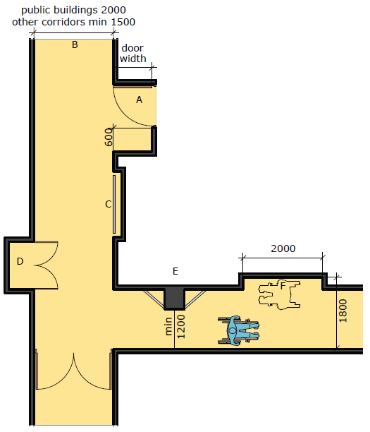

Annex 3: Referring to persons with disabilities
PREFERRED TERMINOLOGY | AVOID PHRASES LIKE
Person with a disability/persons with disabilities (term used in the Convention on the Rights of Persons with Disabilities)  A woman/ man with a disability/disabilities | The disabled / disabled people or disabled person / handicapped / handicapped person/ invalid
Person born with a disability  Person with a disability from birth | Birth defects / deformity
Disability community | Disabled community
Person who is blind (blindness refers to loss of sight)  Person with visual impairment (visual impairment refers to partial loss of sight within a range from slight to severe) | The Blind/the visually impaired
A deaf person / deaf community (deafness refers to loss of hearing)  Person with hearing impairment (hearing impairment refers to partial loss of hearing within a range from slight to severe) | The deaf /deafmute/deaf and dumb
Person with a physical disability /person with a mobility impairment / crutch user /person who uses a walker | Cripple/crippled
Wheelchair user | Confined to a wheelchair /Wheelchair-bound
Person with cerebral palsy (cerebral palsy may be replaced with the name of another condition, such as for instance, spinal cord injury, muscular dystrophy, etc.)  Person with multiple disabilities | Afflicted by multiple sclerosis, cerebral palsy, etc.  Suffers from multiple sclerosis, cerebral palsy, etc.
Seisure | Attack, spells, fits
Person with muscle spasms | Spastic
A person of short stature  Little person / little people | Dwarf / dwarves / midget(s)
Person with an intellectual disability  Person with learning disabilities  Person with developmental disabilities  Person with autism | Idiot  Mentally retarded/ slow  A retard  Crazy  Maniac
Person with mental health issue(s)  Person with depression  Person with schizophrenia  Survivor of psychiatric services  Persons with psychosocial disabilities | Crazy/ demented /mad  Culture-specific descriptions, e.g., “gone with the fairies”
Person with Down’s Syndrome | Mongoloid, mongolism
Accessible seating, parking, washrooms | Handicapped seating, parking, washrooms
Person without a disability  Non-disabled person | Normal / able-bodied (implies that persons with disabilities are abnormal and not able)  “Healthy” -- when used for comparison with the "disabled" – “Healthy” implies that the person with a disability is unhealthy. In fact, many persons with disabilities are in excellent health.
Reasonable Accommodation | Burden

Annex 4: Sample meeting evaluation form
Accessibility Evaluation: Satisfaction with accessibility facilities and services
1. To what extent did the following facilities and services satisfy your accessibility needs? | Fully———-  (1) | To a great extent  (2) | Some-what  (3) | To a lesser extent  (4) | Not at all——  (5)
a. Website for the meeting
Please provide any comments:

b. Documentation in accessible formats
Please provide any comments:

c. Physical accessibility of the venue
Please provide any comments:

2. Please provide any additional comments on the Meeting or suggestions on improvements, including for better accessibility:

Annex 5: Mobility ramps
Features to consider when installing ramps:
-Ramps are installed at entrance ways with steps and include sufficient turning space.
-Ramps do not exceed the maximum nine metre distance that most wheelchair users find maneuverable.

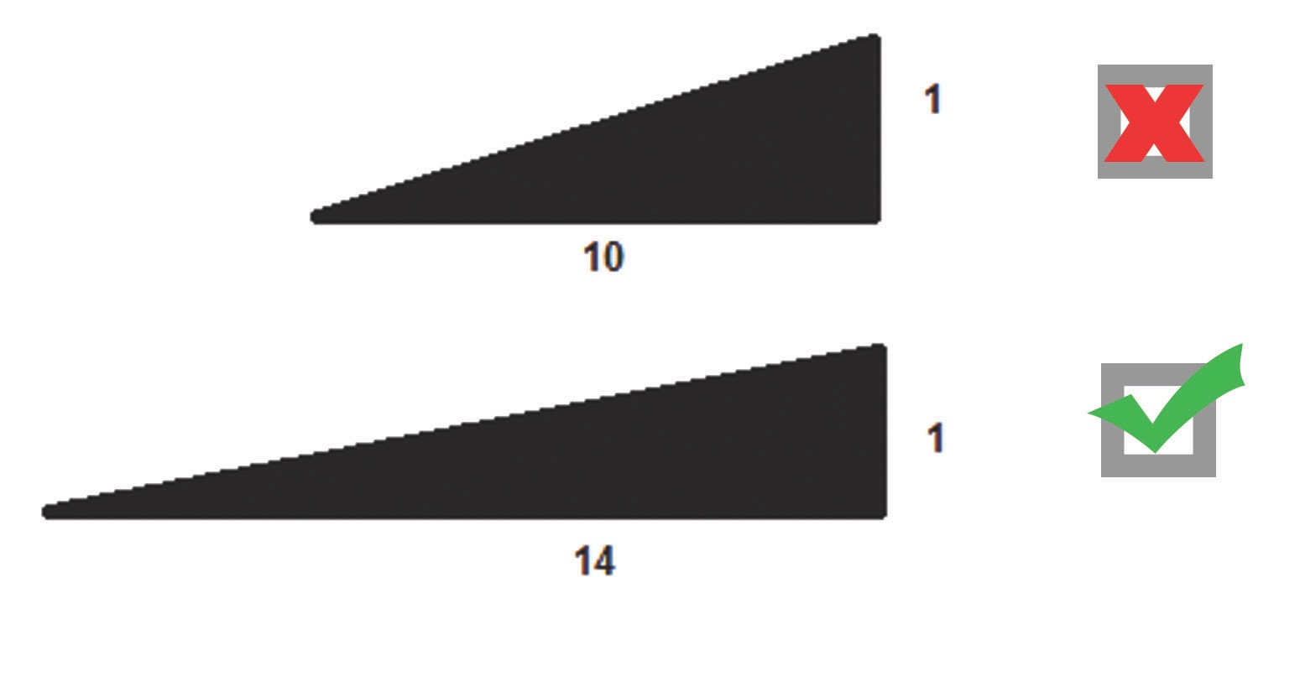

Glossary
Access audits of public buildings: Audits of plans, construction, maintenance and related services provided on premises. Access audits include recommendations to make buildings fully accessible, specifying actions to be taken within a reasonable timeframe.
Accessible formats: The provision of informational materials in mediums accessible to persons with diverse disabilities. Examples include Braille versions of text, large print, and plain-language audio and captioning.
Accessibility: The degree to which information and the physical environment can be used or accessed by as wide a group of people as possible. As such, physical environments and forms of information are those that can be used or accessed by all individuals, irrespective of any disability they may have.
Accessibility checklist: In order to confirm the accessibility of a meeting venue, a checklist of requirements can be compiled and tailored to specific guests’ needs. An accessibility assessment should include the meeting space and facility in general. Numerous example checklist points are included in this Guide.
Alternative text (alt-text): When a presentation slide contains non-text elements, namely images, graphics, logos or flow charts, those elements are inaccessible for people who are blind or deafblind and use assistive technology, such as screen readers. These elements should be described in text attached to the image but hidden from sight; typically used to provide a narrative description of the item for persons with visual disabilities.
Assistive device: A device that has been designed, manufactured or adapted to assist a person in performing a particular task. Examples include white canes, hearing aids, crutches, wheelchairs and tricycles.
Assistive listening systems: The use of devices such as those for amplification of speech and the establishment of more accessible sound to noise ratios.
Attendant care: Personal assistance for individuals with physical disabilities, in order to aid them in the performance of everyday activities such as using bathroom facilities, mobility, eating, dressing and taking medication.
Audio induction loop/ audio-frequency loop/ hearing loop: Assistive technology for persons who are deaf or hard of hearing. A loop carrying baseband audio-frequency currents amplifies a target sound (for example, the contributor speaking in a meeting) so that listeners can hear the sound more clearly and loudly.
Auditory requirements: The specific needs of a deaf, deafened or hard of hearing person. In the context of a meeting, this might include the provision of captioning services, sign language interpreters and assistive listening systems.
Barriers: Persons with disabilities face a multitude of social, economic, physical, political, informational, communicational and attitudinal barriers to their full and effective participation in education, employment, decision making and other essential activities.
Barrier-free: Both information and physical environments that are designed or adapted to remove barriers to persons with disabilities.
Braille: A tactile medium of reading texts for blind persons and persons with other visual disabilities. Braille is embossed on paper and has more recently also become available on computer screens and other electronic devices thanks to refreshable Braille displays. Braille can be written with a slate and stylus, a Braille writer or on computers that print with a Braille embosser.
Captionists: Communication facilitators who provide real-time typed captioning of spoken language to allow understanding by participants who are deaf or hard of hearing. Two common formats used by English language captionists are CART and C-Print.
Communication: Spoken language, sign language, displays of text, Braille, tactile communication, large print, and accessible multimedia, as well as written, audio, plain-language, human-reader and augmentative and alternative modes, means and formats of communication, including accessible information and communication technology.
Convention on the Rights of Persons with Disabilities: Adopted by the United Nations General Assembly, after five years of negotiation, through resolution 61/106 on 13 December 2006. The Convention’s fundamental aim is to establish and safeguard protection of persons with disabilities and guarantee their basic human rights.
DAISY: Digital Accessible Information Systems allow books and written materials to be listened to in an audible format, viewed as large print or with conducive color contrast on digital devices, or to be read in Braille on refreshable Braille displays. Users can navigate written materials using DAISY players, computers with DAISY software, mobile phones and mp3 players.
Deaf: Severe or total hearing loss, resulting in minimal or no functional hearing in medical terms. In sociological terms, deaf persons are individuals who prefer to communicate using sign language, and participate in deaf culture.
Deafblind: A combination of deafness and blindness, to varying degrees of severity.
Deafened: A deafened person loses their sense of hearing as an adult, and accordingly experiences a different set of issues than a person who has been deaf since birth or childhood. Deafened persons often use written text as a means of communication rather than sign language.
Disability: An evolving concept, disability results from the interaction between persons with impairments and attitudinal and environmental barriers that hinder their full and effective participation in society on an equal basis with others.
Disability Equality Training (DET): Courses developed by persons with disabilities to provide information and raise awareness about life with disabilities.
Discrimination on the basis of disability: Any distinction, exclusion or restriction on the basis of disability that has the purpose or effect of impairing or nullifying the recognition, enjoyment or exercise, on an equal basis with others, of all human rights and fundamental freedoms in the political, economic, social, cultural, civil or any other field. It encompasses all forms of discrimination, including denial of reasonable accommodation.
Diverse disability groups/ persons with diverse disabilities: These terms point to the large heterogeneity among persons with disabilities. Persons with disabilities include not only blind persons, people who use wheelchairs, crutches and other mobility devices, or persons who are deaf and hard of hearing, but also persons with intellectual, learning and developmental disabilities, persons with autism, persons with dyslexia, persons who are deafblind, persons with multiple disabilities, and persons with extensive disabilities. Persons with disabilities include groups that are marginalized, such as children with disabilities, women with disabilities, persons with disabilities living in slums and persons with disabilities living in remote or rural areas.
Disabled People’s Organisations (DPOs): Representative groups of persons with disabilities. Persons with disabilities and their relatives constitute a majority of the staff, board and volunteers of these organisations. A primary aim of these organisations is the empowerment and self-advocacy of persons with disabilities.
EPUB: A mainstream format for published documents and books that follows universal design principles and facilitates accessibility through features such as the mark-up of text, graphs, tables and lists, reflowable and resizable text, and alternative text for images. The format has been developed in close association with the DAISY Consortium, and it is fully aligned with DAISY principles.
Evacuation plans: Procedures for vacating a premises in a short time frame in the case of an emergency. These should be inclusive of the needs of persons with disabilities and should be clearly communicated at the beginning of meetings.
Guide/interpreter: A professional who works with a deafblind individual to facilitate understanding and communication. They offer interpretation typically based on tactile communication method, such as Finger Braille, tactile sign language, print on palm and using a variety of other methods. They also assist the daily mobility and activities of deafblind individuals.
Hard of hearing: Describes a less severe degree of hearing loss than deaf or deafened.
Hearing impaired: This general term can denote both slight and profound hearing loss. Many persons self-describe as ‘deaf’ or ‘hard of hearing’ rather than ‘hearing impaired’, because of the implicit emphasis on deficiency or incompleteness carried by the term.
Impairment: A difficulty in body function or structure that is permanent or temporary. As a result of environmental and attitudinal barriers, impairments lead to disabilities.
Intellectual disabilities: Neurodevelopmental impairments affecting intellectual and adaptive functioning.
International Sign: International Sign (IS) is a dynamic and complex signed communication system that is often used at international meetings. Some practitioners and linguists consider it too variable to be considered a ‘language’, whereas others argue that it is increasingly consistent in its usage in different international contexts. IS is promoted by many as a ‘sign lingua Franca’ to be used in international contexts.
Inclusive environment: An environment that has either been designed and built with the principles of universal design from inception, or else has been adapted to be inclusive of the accessibility and participation of all persons.
Inclusive participation: The removal or minimisation of barriers and changing of attitudes to ensure the full and effective participation of persons with disabilities in society on an equal basis with others.
Language: Spoken and signed languages and other forms of non-spoken languages.
Learning disabilities: A group of impairments of academic, language and speech skills. Examples include dyslexia (reading), dyscalculia (mathematics), and dysgraphia (writing).
Mainstreaming: The systematic integration of the priorities and requirements of persons with disabilities with wider policies and general measures.
Marked-up file: Marked up files include additional elements to add to the clarity of a document. Additions can include changes to structure, added page numbers, section headings, annotations of tables, lists and footnotes, as well as side-notes and explanations of abbreviations and acronyms.
Mobility aid: A device created to aid walking or another form of mobility for persons with mobility disabilities. Examples include canes, crutches, wheelchairs and scooters.
Mobility disability: A difficulty in a person’s ability to move, often necessitating the use of a mobility aid. Mobility disabilities may result from conditions such as cerebral palsy, multiple sclerosis, diabetes and muscular dystrophy.
Note-taking: Persons with a range of disabilities may benefit from note taking support during a meeting, in order to allow the individual better understanding of and reference to essential points being made.
Persons with disabilities: Individuals who have long-term physical, mental, intellectual or sensory impairments that, in interaction with various barriers may hinder their full and effective participation in society on an equal basis with others.
Plain language: Words in documents are direct and organized logically. Sentences are constructed clearly and simply. Only necessary words are used and long sentences with complex construction are avoided.
Print disability: Difficulty reading printed text due to visual, physical, perceptual, developmental, cognitive or learning disabilities.
Psychosocial disabilities: Mental illnesses that are caused or exacerbated by social experience, in addition to cognitive and behavioural functions.
Real-time captioning: An instant translation of spoken language into written text, displayed on a computer screen or projected onto a larger display surface. Real-time captioning allows meeting participants who are hard of hearing or deafened to understand what is said. This may be done by a captionist who is physically present at the meeting, or sometimes by a remote captionist who receives an audio signal and relays the captioned text via the internet.
Reasonable accommodation: Necessary and appropriate modification and adjustment not imposing a disproportionate or undue burden, where needed in a particular case, to ensure to persons with disabilities the enjoyment or exercise on an equal basis with others of all human rights and fundamental freedoms.
Sans serif: Fonts/typefaces that do not have serifs – the tail-like strokes at the start and end of a letter. The most widely used serif font is Times New Roman. Examples of sans serif fonts are Arial, Helvetica, Verdana, Futura, Univers and Franklin Gothic. The Canadian National Institute for the Blind has developed an accessible design standard for printed material, called Clear Print (see reference below).
Scent-free environment posters: Posters and other materials that are purposefully manufactured without scented products. Chemicals used in scented products can cause medical reactions in individuals with fragrance sensitivities, asthma, allergies and additional conditions and disabilities.
Sign language: A visual language used by deaf and deafblind people as a means of communication. Sign languages make use of hand shapes, hand movement, arms and body, as well as facial expressions to convey meaning. Sign languages are organic languages that have their own linguistic rules and grammatical features that are distinct from spoken languages. Sign languages vary from country to country, with an estimated 137 international variants.
Sign language interpretation: A service whereby experts with highly specialized skills in a particular sign language interpret other forms of communication into that sign language to allow deaf and hard of hearings persons to understand and communicate.
Space allowance: The careful planning of physical layouts of venues to allow inclusive and unhindered movement of persons with mobility disabilities.
Tactile surfaces: Raised floor surfaces are provided at stairs, turns, doors, inclines, escalators and other physical features, to inform and alert blind persons, persons with reduced vision and deafblind persons.
Unicode fonts: A system of numbering letters that incorporates thousands of different letters and characters from many different languages into one font.
Universal design: The design of products, environments, programmes and services to be usable by all people, to the greatest extent possible, without the need for adaptation or specialized design.
Visual disability: A reduced ability to see, which cannot be adequately alleviated by glasses or conventional medicine.

Resources
Below is a list of resources that have informed this Guide and the glossary. It is hoped that the resources may be useful to readers wishing to deepen their understanding of certain aspects of disability-inclusivity.
ADA (Americans with Disabilities Act), 2010 Standards for Accessible Design: http://www.ada.gov/regs2010/2010ADAStandards/2010ADAStandards.pdf
Assistive Technology Development Organisation (ATDO): http://www.normanet.ne.jp/~atdo/english.html
Canadian National Institute for the Blind, Clear Print design standard: http://www.cnib.ca/en/services/resources/Clearprint/Documents/CNIB%20Clear%20Print%20Guide.pdf
Centre for Excellence in Universal Design, 7 principles: http://universaldesign.ie/what-is-universal-design/the-7-principles/
DAISY Consortium: http://www.daisy.org
Developmental Disabilities Resource Centre (DDRC) Glossary of Developmental Disability Terms: http://www.ddrcco.com/resources-and-training/glossary-of-developmental-disability-terms.php
DO IT (Disabilities, Opportunities, Interworking and Technology), Glossary of disability-related terms: https://www.washington.edu/doit/glossary-disability-related-terms
European Disability Forum, Disability Glossary: http://www.edf-feph.org/Page_Generale.asp?DocID=12536
Government of Ontario, Information and Communications Standard: http://www.mcss.gov.on.ca/documents/en/mcss/accessibility/iasr_guides/info_en.pdf
International Organization for Standarization, Ergonomics - General approach and principles: https://www.iso.org/obp/ui/#iso:std:iso:26800:ed-1:v1:en
Microsoft, Mark up files: http://www.microsoft.com/en-us/dynamics/marketing-customer-center/mark-up-files.aspx
National Disability Authority (NDA, Ireland), Centre for Excellence in Universal Design: http://universaldesign.ie
O’Reilly online publishing, Accessible EPUB3 (Matt Garrish): Free download at http://www.oreilly.com
University of Leeds, Disability Equality Training: http://disability-studies.leeds.ac.uk/files/library/Campbell-dis-equality-training.pdf
UN Convention on the Rights of Persons with Disabilities: http://www.un.org/disabilities/convention/conventionfull.shtml
UNESCAP, Incheon Strategy to “Make the Right Real” for Persons with Disabilities in Asia and the Pacific: http://www.unescapsdd.org/files/documents/PUB_Incheon-Strategy-EN.pdf
UNESCAP, Social Development Division website - disability: www.unescapsdd.org/disability
World Federation of the Deaf, Perspectives on the Concept and Definition of International Sign: http://www.wfdeaf.org/wp-content/uploads/2012/03/Perspectives-on-the-Concept-and-Definition-of-IS_Mesch-FINAL.pdf.

World Health Organisation, World Report on Disability: http://www.who.int/disabilities/world_report/2011/en/

Checklists
The checklists below build on the structure of the Guide’s chapters to offer specific action-points for the planning and conduct of disability-inclusive meetings.

Checklist: Selecting an accessible venue and hotel
- Venues and hotels have spacious corridors and ramps — or sufficient space to set up ramps — for the easy mobility of wheelchair users.
- Hotel rooms are accessible to guests with disabilities.
- Staff at the venue and hotel are sensitive to the needs of persons with disabilities.
- There are disability-friendly emergency evacuation routes, including flashing lights and SMS services for persons who are deaf or hard of hearing.
- Doors are light-weight, can be easily opened using only one hand in a closed fist, and include door-stops; door-handles are 80cm-100cm above floor level.
- Accessible bathrooms are located near to the meeting space.
- Sufficient space is allocated for persons with assistive devices and service dogs as well as interpreters, guides and captionists.
- A raised platform is provided for wheelchair users, little persons, and those who are unable to stand for extended periods, to use whilst delivering speeches.
- Floor surfaces are not slippery and allow for the easy mobility of wheelchair users and other participants with mobility disabilities.
- The venue has a high-quality sound system, with multiple microphones, to meet the auditory requirements of all participants.

Checklist: Information and communication
- Meeting websites conform to international accessibility standards, such as WCAG 2.0.
- Language used in key documents is straightforward and easy to understand.
- Online, print materials and presentations use readable fonts, sized 12-18, and include adequate leading - or space between lines.
- When emphasis is needed, bold or larger font is used, since this is easier to read than italics or upper case letters.
- Materials are printed on matt, non-glossy paper in order to avoid glare.
- PowerPoint slides contain no more than six lines of text per slide.
- High-contrast color combinations are used; black and white is easiest to read.
- Electronic copies of all documents are made available to all participants and interpreters ahead of the meeting, via USBs, CDs and email.
- Video clips include signed interpretation and/or are captioned.
- The location of the following features are clearly signposted and communicated in accessible formats, such as Braille and voice audible announcements: toilets, reception concierge, registration desk, key codes.

Checklist: Preparations in advance of meetings
- Arrange appropriate support personnel, including interpreters, captionists, volunteers and assistants well in advance of the meeting.
- Brief organizers, staff and media representatives on disability inclusion in advance of the meeting.
- Consult with participants with disabilities on allocation of time for substantive sessions and breaks in advance of the meeting.
- Identify providers of accessible transportation and book services far in advance of the start of the meeting.

Checklist: Conducting disability-inclusive meetings
- At the opening of the meeting, the chair informs all participants about the layout of the meeting venue, the meeting agenda and services provided — such as interpretation services, attendant care, and note taking and captioning services.
- The chair asks participants to briefly introduce themselves each time they make a contribution to the meeting, and encourages all presenters to speak clearly and at a moderate pace.
- Volunteers are on hand to respond to the needs of all participants.
- Outcome documents of meetings are produced in accessible formats and projected onto a clearly visible screen during the final session of meetings.

Checklist: Interacting with persons with disabilities
- Persons with disabilities are first and foremost persons; they are not identified solely in terms of impairments or conditions.
- Persons with disabilities are not regarded as victims, objects of pity or charity.
- Persons with disabilities are recognized as being entirely capable of making their own decisions and leading meaningful, independent lives.
- When conversing with people who use wheelchairs, especially for extended periods of time, sit at a chair in order to talk from a similar height.
- When talking to a person who is deaf or hard of hearing, be as expressive with your face and body as possible. If it is not possible to communicate using sign language or by speaking slowly and clearly, write on a memo pad.
- Ask before guiding or assisting persons with disabilities. Remember, not every person with a disability needs help all the time.
- Avoid making assumptions about persons with intellectual disabilities, such as the idea that they may not be socially adept or able to manage interactions with different people.

Checklist: Compiling an evaluation form
- Using ‘to what extent’ questions allows for the collection of comparable, quantitative responses.
- Including additional space for written comments allows participants to offer specific feedback about the meeting.
- Sub-categories of questions allow for specific and targeted responses. For example, under a general question about the accessibility of information materials and services, there should be an opportunity for participants to rate and comment on websites, documentation, Braille and DAISY formats of materials, sign language services, captioning and more.

Consulting with persons with disabilities throughout the process of planning a disability-inclusive meeting is the most effective way to ensure that nothing is overlooked.

ESCAP, Disability at a Glance 2012. Available from: http://www.unescapsdd.org/files/documents/PUB_Disability-Glance-2012.pdf.
See: https://esango.un.org/civilsociety/displayConsultativeStatusSearch.do;jsessionid=2E475700BFEFF0FC3780FF33A18CE6E6.
ESCAP, Incheon Strategy. Available from: http://www.unescapsdd.org/files/documents/PUB_Incheon-Strategy-EN.pdf
Sustainable Development Goals, adopted in September 2015: https://sustainabledevelopment.un.org/?menu=1300.
Sendai Framework, available from: http://www.preventionweb.net/files/43291_sendaiframeworkfordrren.pdf.
Available from: http://www.un.org/disabilities/convention/conventionfull.shtml.
Ibid., appendix II.
See article 1 of the Convention on the Rights of Persons with Disabilities.
ISO, 2011, Ergonomics – General approach principles and concepts, https://www.iso.org/obp/ui/#iso:std:iso:26800:ed-1:v1:en.
See article 9 of the Convention on the Rights of Persons with Disabilities.
See article 2 of the Convention on the Rights of Persons with Disabilities.
See: http://www.ncsu.edu/ncsu/design/cud/about_us/usronmace.htm.
1) Equitable use; 2) flexibility in use; 3) simple and intuitive use; 4) perceptible information; 5) tolerance for error; 6) low physical effort, and 7) size and space for approach and use. See: http://universaldesign.ie/what-is-universal-design/the-7-principles/.
See article 2 of the Convention on the Rights of Persons with Disabilities.
Optional Protocol, Article 1 http://www.ohchr.org/EN/HRBodies/CRPD/Pages/OptionalProtocolRightsPersonsWithDisabilities.aspx.
Image source: James. D. Harrison, Cork Institute of Technology, presentation slide from the ESCAP-South-South Programme on Accessibility for Persons with Disabilities, 10-19 December 2014 in Guangzhou-Macao-Hong Kong, China.
For a Disability Equality Training Trainer’s Guide, see: http://disability-studies.leeds.ac.uk/files/library/Campbell-dis-equality-training.pdf.

